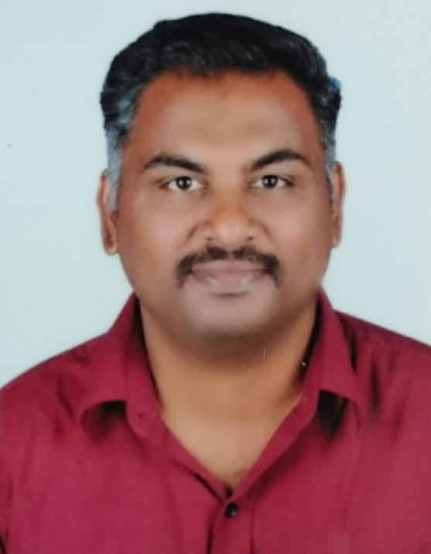
M.H.MOHAMED FAIZAL
Assistant Professor
Department of Electronics & Communication Engineering.
Bharathiyar College of Engineering & Technology
Karaikal, Pondicherry state, India
Mail: fai.ece@gmail.com , faizal_ece86@yahoo.co.in
Cell: +91 9500422702

OBJECTIVE

- To secure a challenging position in the field that will utilize my skills and knowledge to the maximum and provide an opportunity for my career advancement as well.

ACADEMICS

QUALIFICATION | COLLEGE | PERFORMANCE | YEAR
M.E  (Computer and Communication Engineering) | Pavendar Bharathidasan College of Engineering & Technology, Trichy, Tamil Nadu, India | 7.80 CGPA | NOV’2012
B.E.  (Electronics and Communication Engineering) | Bharathiyar College of Engineering and Technology, Karaikal, Pondicherry State, India | 7.62 CGPA | MAY’2008
DIPLOMA  (Electronics and Communication Engineering) | Karaikal Polytechnic College, Karaikal, Pondicherry State, India | 81.42 % | APRIL’2005
SSLC | M.E.S High School, Karaikal, Pondicherry state, India | 85.2 % | MARCH’2002

TECHNICAL SKILLS

- Hardware Skills
Computer Installation & Trouble Shooting, Electronic project design, Communication project design
- Software Skills

MATLAB, LABVIEW, NS2, PSPICE, PROTEUS
Total Experience: 8. 8 Years

ORGANIZATION | POSITION | FROM | TO | DURATION
Bharathiyar college of Engineering & technology, Karaikal | Assistant Professor | 16-7-2012 | Till date | 6 years 8 months
Bharathiyar college of Engineering & technology, Karaikal | Lecturer | 14-6-2010 | 2-9-2010 | 3 months
E.G.S Pillai Engineering College, Nagapattinam | Lecturer | 18-8-2009 | 8-6-2010 | 10 months
E-Global Network Solution, Karaikal | Network Associate | 11-6-2008 | 28-5-2009 | 11 months

INTERNATIONAL JOURNAL | INTERNATIONAL CONFERENCE | NATIONAL CONFERENCE | WORKSHOP
5 | 4 | 2 | 3

Subjects Taught:

- Microprocessor and Microcontrollers,
- Digital Electronics,
- Linear and digital control system
- Microwave and optical engineering,
- System Design using Integrated Circuits,
- Satellite Communication
- Digital Communication,

Personal details:

Name : M.H.Mohamed Faizal

Father Name : A.Mohamed Hussain

Address : 169, P.S.R Gold Nagar,
7th cross Street,
Pondicherry state,
Karaikal-609602

Date of Birth : 1.10.1986

Nationality : Indian

Community : Muslim

Marital status : Married

Employment Status : Full Time

DECLARATION:
I hereby declare that all the above information furnished by me in this resume is correct to the finest possible extent till date.

Date: M.H.MOHAMED FAIZAL

